Zachary White
Darrell Payne
CSD 420 – Advanced Java Programming
09/25/2026

MySQL / JDBC Setup and Verification

1. Overview
This project verifies a working development environment consisting of Java, the NetBeans IDE, and a MySQL 8.0 database server, connected through JDBC (Java Database Connectivity). The goal was to configure a MySQL user account and database, grant that account the correct privileges, and confirm connectivity from a Java application using a custom-written test program. The sections below walk through the environment setup, the database configuration, the Java/JDBC connection test, and the final verification results. The complete Java source code is included as a separate attachment.

2. Environment Setup
The JDK and NetBeans IDE were installed first and confirmed to run correctly. MySQL Server 8.0 (Community Edition) was already installed via previous course, instead of deprecating existing projects I used 8 instead of 5.
One early issue: the machine's PATH environment variable did not include the MySQL “bin” directory, which prevented the mysql command-line client from being recognized in the Windows terminal. This was resolved by navigating directly into the MySQL bin folder before issuing commands (and later adding the folder to the system PATH permanently).
Figure 1 shows a terminal session connected to the server as the student1 account, confirming the current user and listing the available databases.
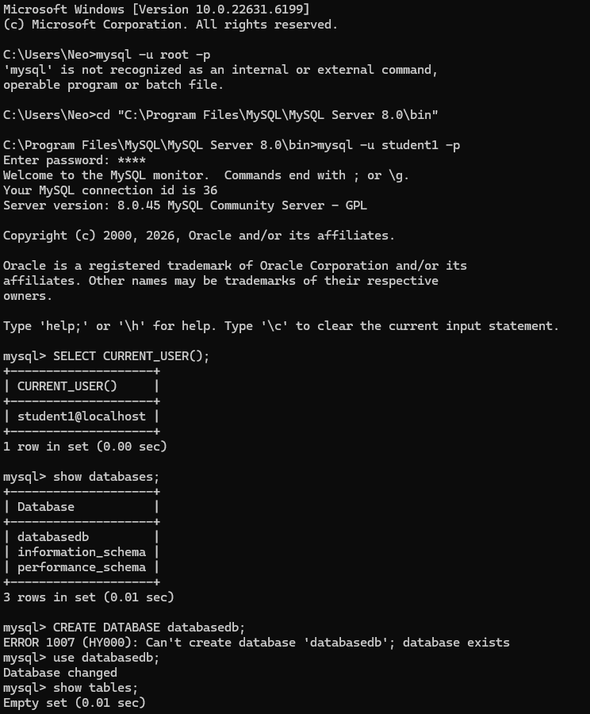
Figure 1 - Command-line connection as student1, confirming current user and available databases.

3. Database and User Configuration
Per the assignment requirements, the database was created with the name databasedb, and a dedicated MySQL account, student1, was created with the password pass and granted full privileges. A test table, address_test, was created and populated with three sample rows to give the Java application data to query.
A brief permissions issue came up along the way: MySQL Workbench initially reported “Access denied for user student1@'localhost'” because the account had not yet been created on that particular server instance. Re-running the account creation and privilege grant as root resolved the problem.
Figure 2 shows the table being created and populated, along with a SELECT query confirming the three rows of sample address data.
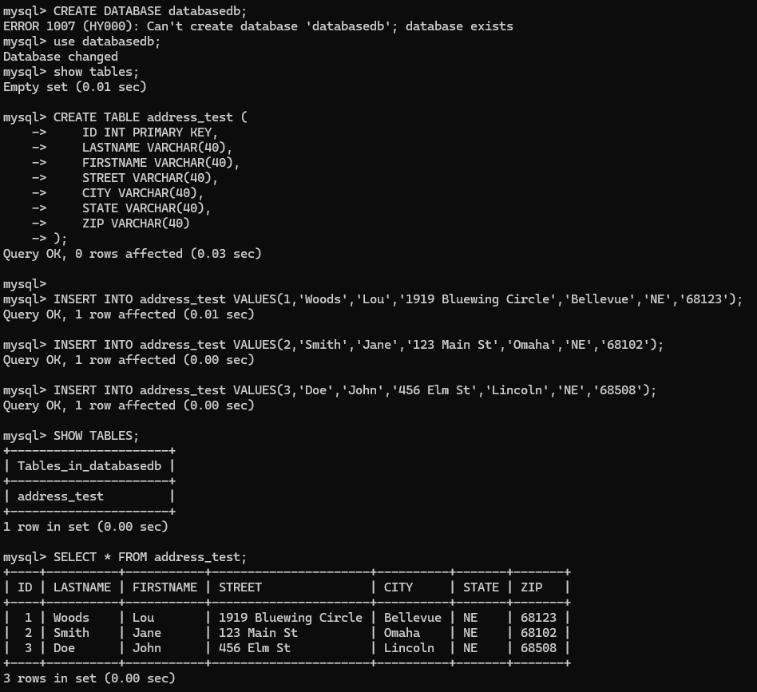
Figure 2 - Creating and populating the address_test table in databasedb.

4. Java / JDBC Test Application
With the database configured, a Java class was written to confirm that a Java application running inside NetBeans could successfully connect to MySQL using the JDBC driver (MySQL Connector/J). The program performs four checks:
- Verifies that the database connection is live.
- Prints environment and version details pulled from the JDBC DatabaseMetaData object (driver name/version, database product/version, JDBC URL, connected user, Java runtime version).
- Confirms the connected user and server version directly from a SQL query.
- Reads and displays the contents of the address_test table in a formatted, table-style layout.
The full annotated source code (DatabaseTest.java) is included as a separate attachment alongside this document.

5. Troubleshooting Notes
Two issues came up while connecting the Java application to MySQL:
- Driver not found: an early run produced java.sql.SQLException: No suitable driver found. This was caused by the MySQL Connector/J JAR not actually being attached to the NetBeans project's classpath, and was fixed by adding the correct Connector/J 26.x JAR ) which I had found on Oracle’s dev site.
- SSL/timezone warnings: because the server is MySQL 8.0 rather than 5.x, the JDBC URL was updated to include useSSL=false&serverTimezone=UTC to avoid SSL and timezone-related connection warnings common with newer MySQL versions.

6. Verification Results
After resolving the driver classpath issue, the application was rebuilt and run successfully in NetBeans. The console output, shown in Figure 3, confirms a valid connection, reports the JDBC driver name and version, the MySQL server version (8.0.45), the active database, the connected user (student1@localhost), and displays the three rows from the address_test table in a formatted layout. The build completed with a BUILD SUCCESSFUL status and no exceptions were thrown, confirming the environment is fully and correctly configured.
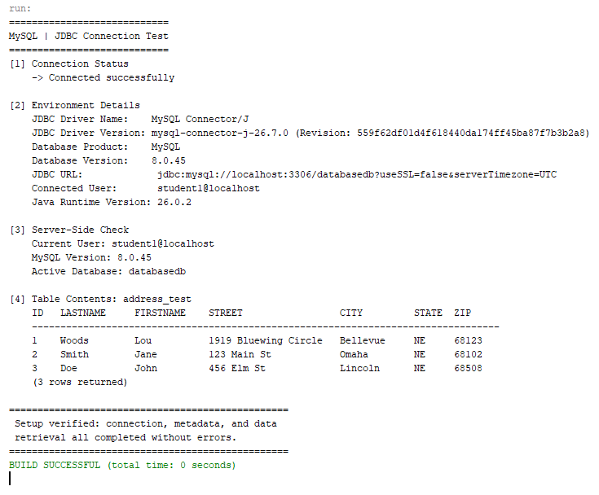
Figure 3 - Successful NetBeans run showing connection details, metadata, and table contents.

7. Conclusion
This exercise confirmed that Java, NetBeans, and MySQL 8.0 are correctly installed and able to communicate through JDBC. The student1 account was successfully configured with access to the databasedb database, and the accompanying Java test program was able to connect, query server metadata, and retrieve table data without error.

